Create war on Jenkins slave and deploy it on tomcat server

* Shweta Raut

Create Jenkins slave from node

Configure in backend

* Install java-17
* Install maven, tomcat-10
* Start tomcat server

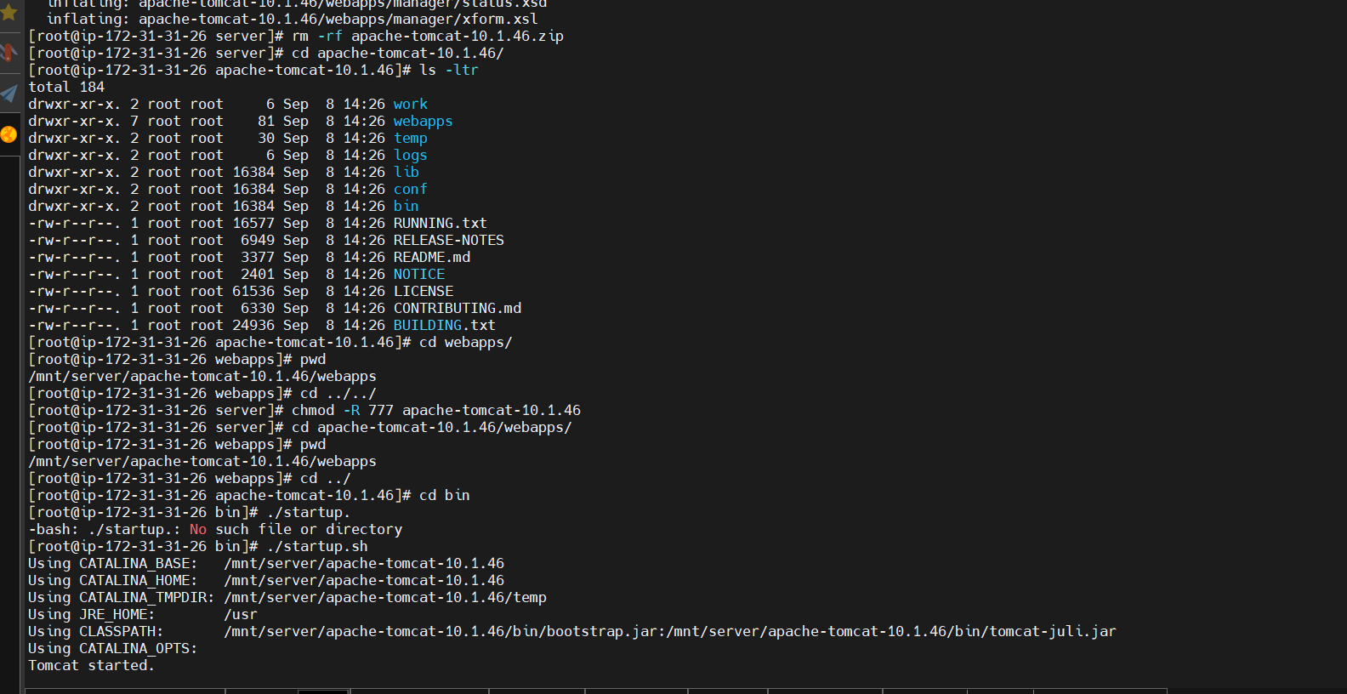

Create freestyle job run on Jenkins slave

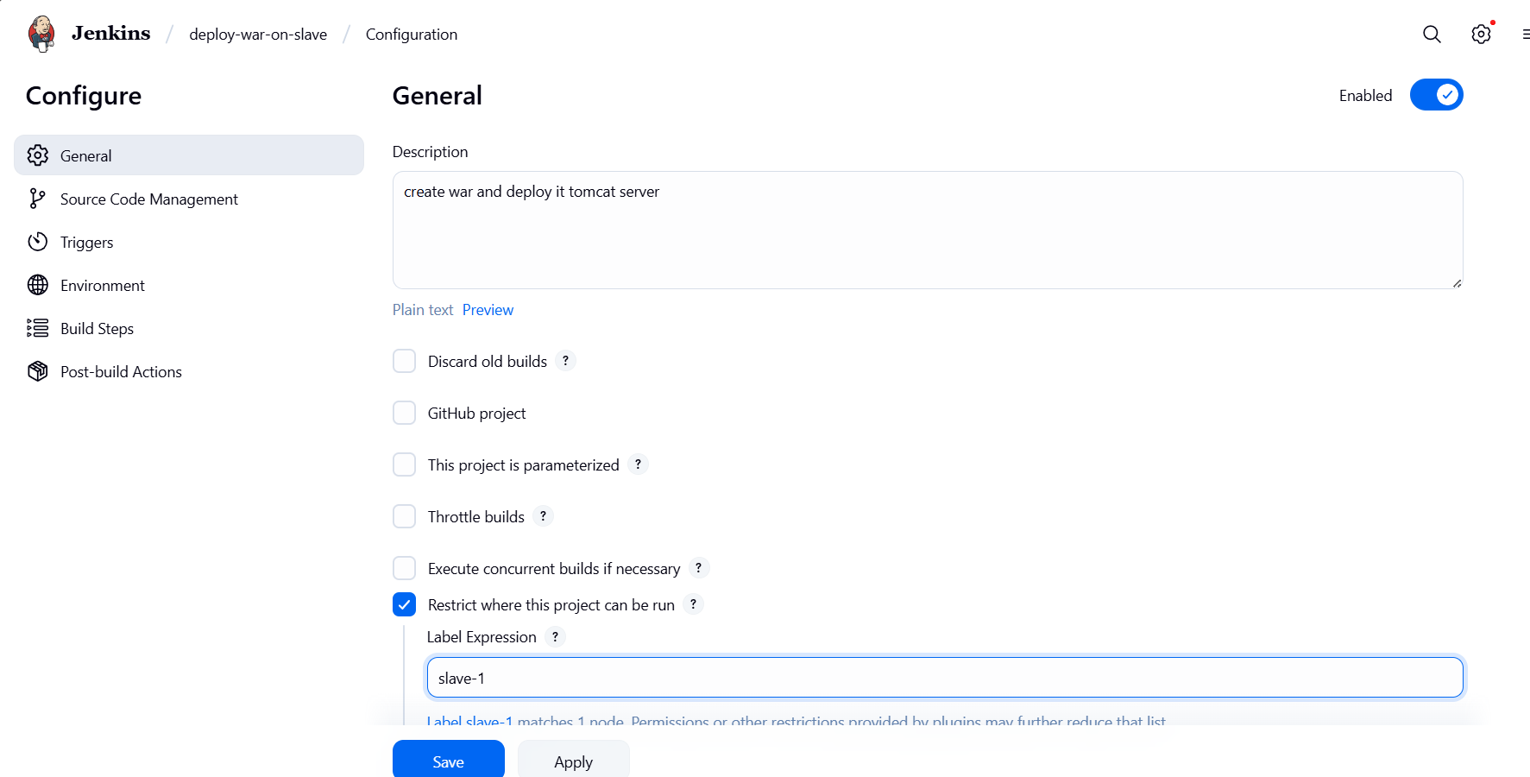

Add git repository

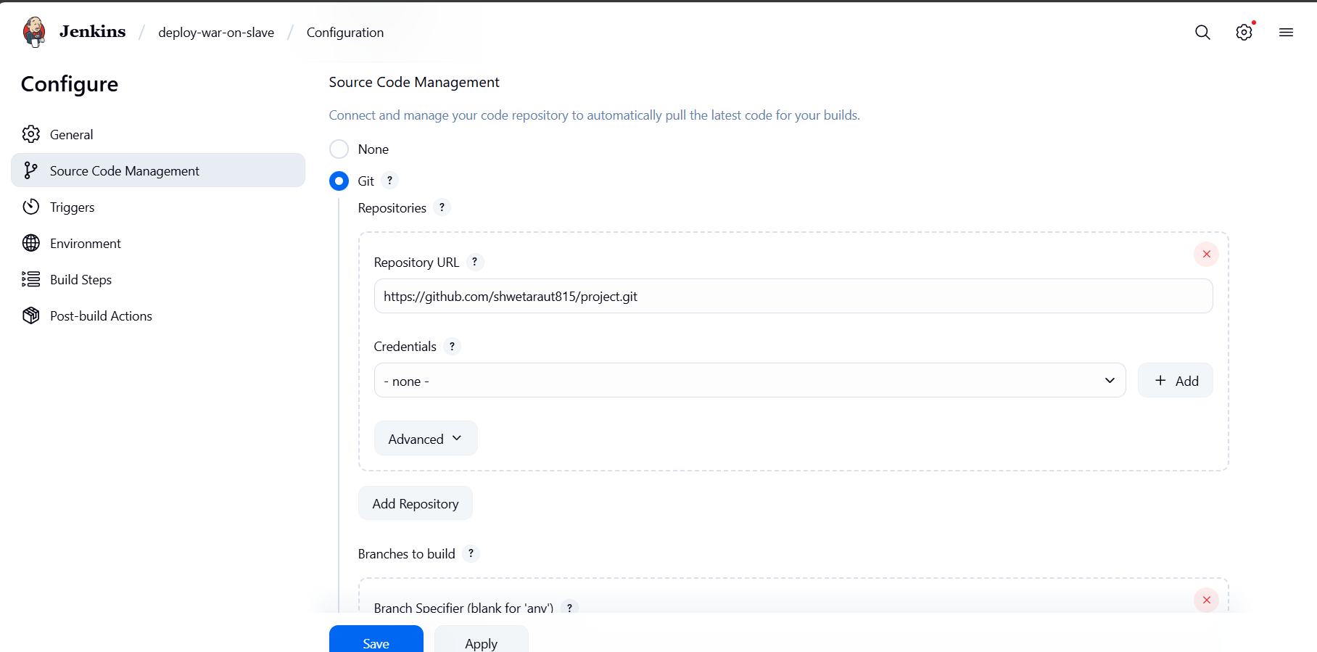

Integrate maven with Jenkins

mvn clean install

copy created war in tomcat-home/webapps folder

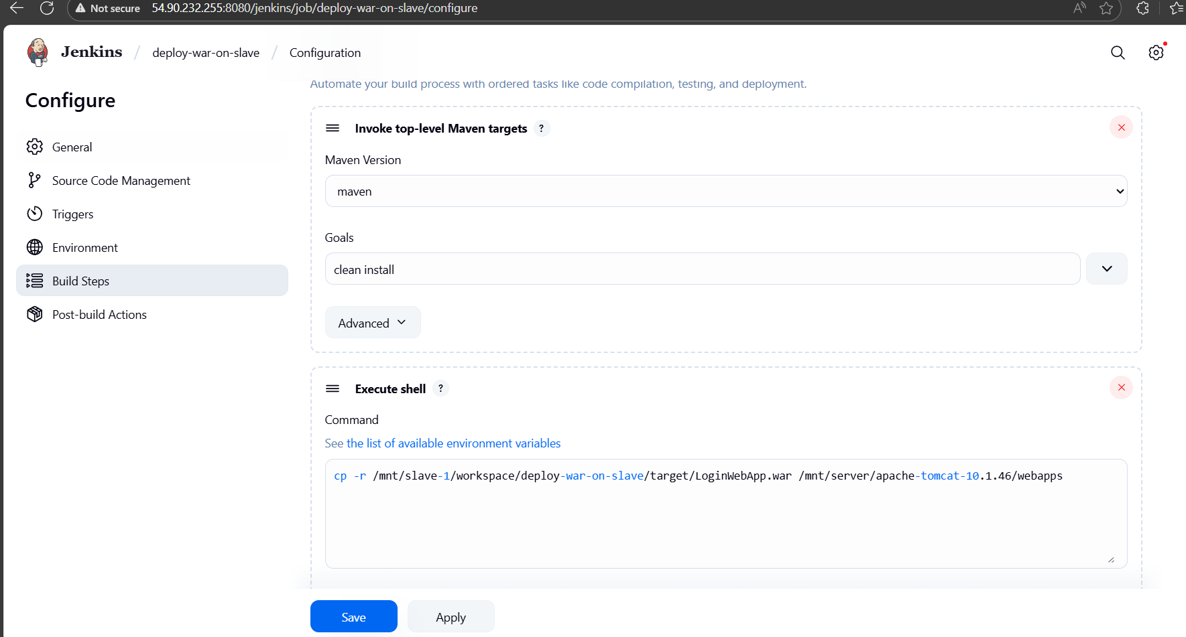

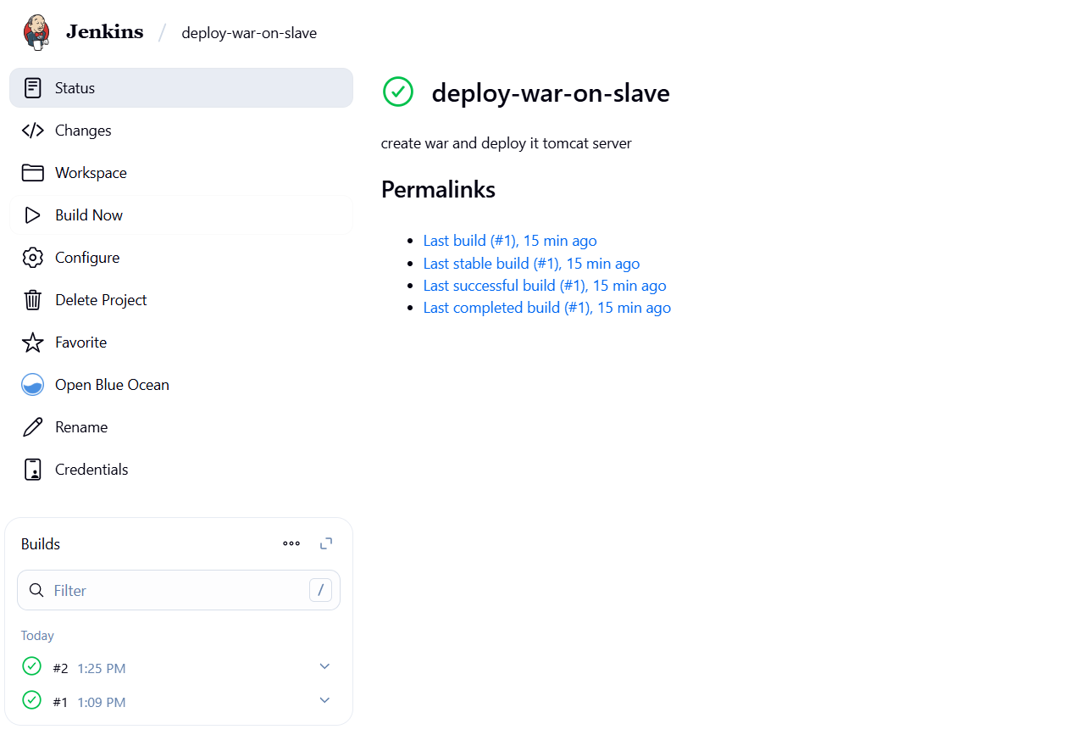

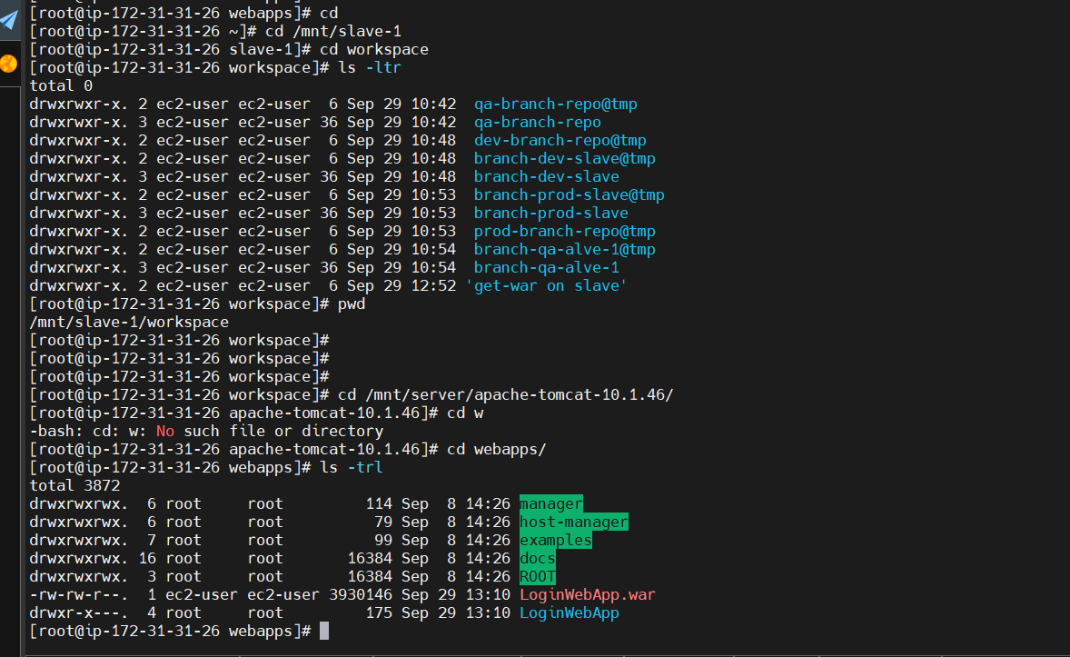

Check access on web application on browser

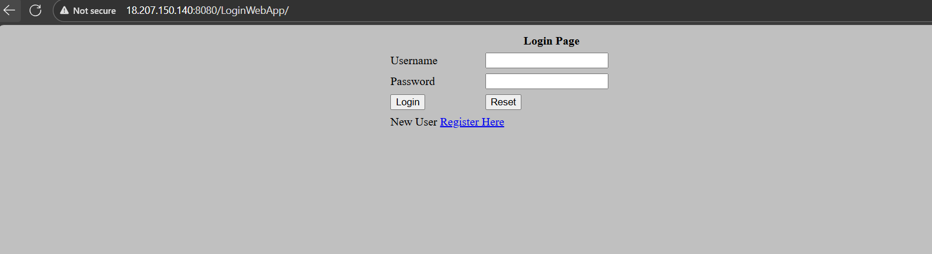

Done !!!!!!!!!!!!!!!!!!!!!